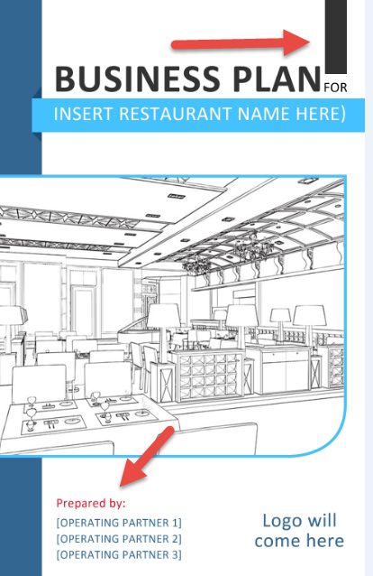
COMEBACK BUSINESS PLAN

Overview

Based on the proposed guidelines that are being floated, as well as those that are already in place, a phased-in reopening that limits capacity to 50% or less of total dine-in seating, will probably be the New Normal. Other restrictions may include requirements for protective gear to be worn by service staff, social distancing of patrons waiting for a table, disposable menus and table sanitation guidelines, to name a few
For you to come back from the Covid-19 pandemic, you must prepare a plan to change the way you do business in which best serves the interest of public health. Public health includes your staff and your guests.
This planning guide is intended to help identify and execute changes that communicate a safe and sanitary environment and instill confidence in our staff and guests that you can provide a safe and exceptional guest experience.
You also need to effectively communicate the plan and make some profit.
To do this, your management team will need to update your policies, procedures and systems in each of these areas of your business.
- Health, Safety and Sanitation
- Dining Room Management
- Our Guest Experience
- Marketing Plan
- Financial Forecasting

Section 1 – Health, Safety and Sanitation

Objective and Purpose
The Covid-19 pandemic has necessitated an industry wide push to radically upgrade traditional sanitation standards. New regulatory requirements, some of which are temporary and some that could be permanent, mandate that we change our systems, policies and procedures to new standards.
Key Considerations
- Wellness checks – Staff; guests
- Social distancing – Staff; guests
- Covid-19 Training – Staff
- Job description changes
- Checklist changes
- Protective wear
- Station modifications
- Sanitation procedures
- New equipment, technology, supplies
- 4-wall signage, premise signage
Notes
___________________________________________________________________________
___________________________________________________________________________
___________________________________________________________________________
___________________________________________________________________________
___________________________________________________________________________
___________________________________________________________________________
___________________________________________________________________________
___________________________________________________________________________

Required Actions
Use this form to assign projects and tasks needed to meet the objectives of this plan.
Action required | Assigned To | Date Assigned | Date Due

Section 2 – Dining Room Management

Objective and Purpose
The phased-in approach for reopening our dining room requires that we make significant adjustments to our dining room layout, hosting and guest welcome process, wait list handling and service procedures in order to earn the trust of our guests. Guests must feel assured that we have gone the extra mile to provide a safe and sanitary environment in which they can dine without fear of being infected by our staff or other guests.
Key Considerations
- Guest arrival
- Table spacing
- Social distancing –
  - Service staff
  - Waiting space
  - Restrooms
  - Cashier stands
- Single-use menus
- Table turn sanitation
- Tabletop sanitation
- Wait list management (where?)
- 4-wall signage, premise signage, floor markings
Notes
___________________________________________________________________________
___________________________________________________________________________
___________________________________________________________________________
___________________________________________________________________________
___________________________________________________________________________
___________________________________________________________________________
___________________________________________________________________________
___________________________________________________________________________

Required Actions
Use this form to assign projects and tasks needed to meet the objectives of this plan.
Action required | Assigned To | Date Assigned | Date Due

Section 3 – Our Guest Experience

Objective and Purpose
The goal of any restaurant is to imprint a positive and lasting experience that makes guests want to return. It is typically the sum total of a variety of elements that leaves guests feeling fulfilled and wanting to repeat the experience. The guest experience is influenced through numerous touchpoints the customer encounters during their visit. We call this the guest journey.
The guest journey differs between dine-in, takeout, curbside service and delivery. For this reason, we need to identify the various touchpoints for each of the services we offer incorporate safe, sanitary practices and ensure the guest experience we deliver in the aftermath of Covid-19 is memorable and encourages them to return.
Key Considerations
- Menu offerings
- Supply chain disruption
- Online ordering
- Phone calls
- Delivery touchpoints
- Curbside pickup touchpoints
  - Service
  - Designated wait spots
  - Payment
- Dine-in touchpoints
- Communication
  - Directional signage
  - Sanitation awareness
Notes
___________________________________________________________________________
___________________________________________________________________________
___________________________________________________________________________
___________________________________________________________________________
___________________________________________________________________________
___________________________________________________________________________
Required Actions
Use this form to assign projects and tasks needed to meet the objectives of this plan.
Action required | Assigned To | Date Assigned | Date Due

Section 4 – Marketing Plan

Objective and Purpose
Communicating with our guests has never been more essential than it has during these past few weeks and the weeks and months ahead. Our marketing plan needs to effectively communicate our brand and our devotion to providing a safe and sanitary environment.
Key Considerations
- 4-walls marketing
- Social media
  - Videos
  - Posts
- Website
  - Online orders
  - Menu
  - Takeout, Delivery and Curbside offerings
- Customer database
  - Email
  - Postal
- Personal interactions
  - Verbal invitations to return
  - Inclusions with takeout and delivery orders
- Online Ordering
  - Order acknowledgment
  - Order follow up
Notes
___________________________________________________________________________
___________________________________________________________________________
___________________________________________________________________________
___________________________________________________________________________
___________________________________________________________________________
___________________________________________________________________________
___________________________________________________________________________
___________________________________________________________________________
Required Actions
Use this form to assign projects and tasks needed to meet the objectives of this plan.
Action required | Assigned To | Date Assigned | Date Due

Section 5 – Financial Forecast

Objective and Purpose
The eventual loosening of dine-in restrictions will allow us to begin the return to our core concept of dining room service. The phased-in approach to restoring dining rooms to full capacity almost certainly means that takeout and delivery will remain a significant part of our sales mix. For this reason, we need to modify our financial projections to determine if we can be profitable with reduced dining and make adjustments to our budgets.
Key Considerations
- Sales Mix (Dine-in, Takeout, Delivery)
- Menu costing
- Sales forecasting
- Staff scheduling
- Break-even
- Cash flow projections
- Profit & loss projection
- Budgeting
Notes
___________________________________________________________________________
___________________________________________________________________________
___________________________________________________________________________
___________________________________________________________________________
___________________________________________________________________________
___________________________________________________________________________
___________________________________________________________________________
___________________________________________________________________________

Required Actions
Use this form to assign projects and tasks needed to meet the objectives of this plan.
Action required | Assigned To | Date Assigned | Date Due

